SEC Form 3
FORM 3 | UNITED STATES SECURITIES AND EXCHANGE COMMISSION  Washington, D.C. 20549  INITIAL STATEMENT OF BENEFICIAL OWNERSHIP OF SECURITIES  Filed pursuant to Section 16(a) of the Securities Exchange Act of 1934  or Section 30(h) of the Investment Company Act of 1940
  OMB APPROVAL
  OMB Number: | 3235-0104
  Estimated average burden
  hours per response: | 0.5
1. Name and Address of Reporting Person*  (Street) | 2. Date of Event Requiring Statement (Month/Day/Year)  10/15/2026 | 3. Issuer Name and Ticker or Trading Symbol  Claritev Corp [ CTEV ]  Foreign Trading Symbol
  Main Jennifer Elizabeth
  (Last) | (First) | (Middle)
  C/O CLARITEV CORPORATION
  7900 TYSONS ONE PLACE, SUITE 400
  MCLEAN | VA | 22102
  (City) | (State) | (Zip)
 |  | 4. Relationship of Reporting Person(s) to Issuer  (Check all applicable) | 5. If Amendment, Date of Original Filed (Month/Day/Year)
   | Director |  | 10% Owner
   | Officer (give title below) |  | Other (specify below)
6. Individual or Joint/Group Filing (Check Applicable Line)
Form filed by One Reporting Person
Form filed by More than One Reporting Person

Table I - Non-Derivative Securities Beneficially Owned
1. Title of Security (Instr. 4) | 2. Amount of Securities Beneficially Owned (Instr. 4) | 3. Ownership Form: Direct (D) or Indirect (I) (Instr. 5) | 4. Nature of Indirect Beneficial Ownership (Instr. 5)
Table II - Derivative Securities Beneficially Owned
(e.g., puts, calls, warrants, options, convertible securities)
1. Title of Derivative Security (Instr. 4) | 2. Date Exercisable and Expiration Date (Month/Day/Year) |  | 3. Title and Amount of Securities Underlying Derivative Security (Instr. 4) |  | 4. Conversion or Exercise Price of Derivative Security | 5. Ownership Form: Direct (D) or Indirect (I) (Instr. 5) | 6. Nature of Indirect Beneficial Ownership (Instr. 5)
1. Title of Derivative Security (Instr. 4) | Date Exercisable | Expiration Date | Title | Amount or Number of Shares | 4. Conversion or Exercise Price of Derivative Security | 5. Ownership Form: Direct (D) or Indirect (I) (Instr. 5) | 6. Nature of Indirect Beneficial Ownership (Instr. 5)
Explanation of Responses:
Remarks:
No securities are beneficially owned.
 | /s/ Kent Bartholomew, attorney-in-fact | 10/19/2026
 | ** Signature of Reporting Person | Date
Reminder: Report on a separate line for each class of securities beneficially owned directly or indirectly.
* If the form is filed by more than one reporting person, see Instruction 5 (b)(v).
** Intentional misstatements or omissions of facts constitute Federal Criminal Violations See 18 U.S.C. 1001 and 15 U.S.C. 78ff(a).
Note: File three copies of this Form, one of which must be manually signed. If space is insufficient, see Instruction 6 for procedure.
Persons who respond to the collection of information contained in this form are not required to respond unless the form displays a currently valid OMB Number.
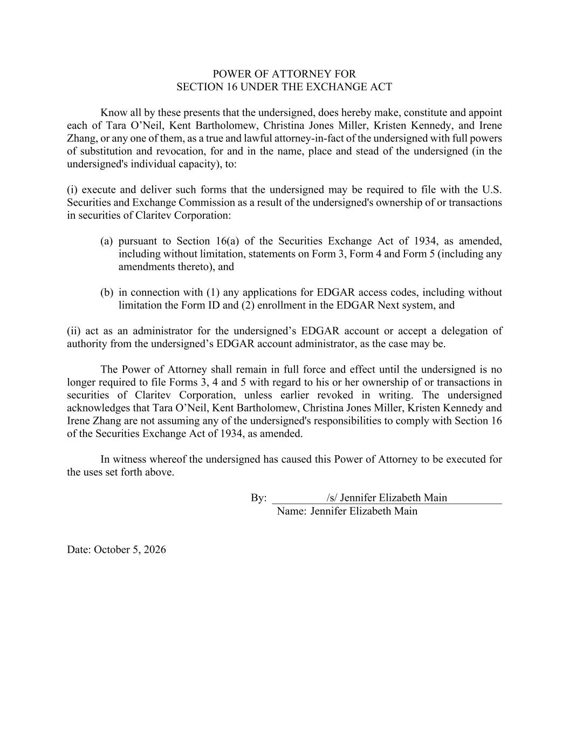
POWER OF ATTORNEY FOR SECTION 16 UNDER THE EXCHANGE ACT Know all by these presents that the undersigned, does hereby make, constitute and appoint each of Tara O’Neil, Kent Bartholomew, Christina Jones Miller, Kristen Kennedy, and Irene Zhang, or any one of them, as a true and lawful attorney-in-fact of the undersigned with full powers of substitution and revocation, for and in the name, place and stead of the undersigned (in the undersigned's individual capacity), to: (i) execute and deliver such forms that the undersigned may be required to file with the U.S. Securities and Exchange Commission as a result of the undersigned's ownership of or transactions in securities of Claritev Corporation: (a) pursuant to Section 16(a) of the Securities Exchange Act of 1934, as amended, including without limitation, statements on Form 3, Form 4 and Form 5 (including any amendments thereto), and (b) in connection with (1) any applications for EDGAR access codes, including without limitation the Form ID and (2) enrollment in the EDGAR Next system, and (ii) act as an administrator for the undersigned’s EDGAR account or accept a delegation of authority from the undersigned’s EDGAR account administrator, as the case may be. The Power of Attorney shall remain in full force and effect until the undersigned is no longer required to file Forms 3, 4 and 5 with regard to his or her ownership of or transactions in securities of Claritev Corporation, unless earlier revoked in writing. The undersigned acknowledges that Tara O’Neil, Kent Bartholomew, Christina Jones Miller, Kristen Kennedy and Irene Zhang are not assuming any of the undersigned's responsibilities to comply with Section 16 of the Securities Exchange Act of 1934, as amended. In witness whereof the undersigned has caused this Power of Attorney to be executed for the uses set forth above. By: /s/ Jennifer Elizabeth Main Name: Jennifer Elizabeth Main Date: October 5, 2026

